**SE411, Spring 2024-2025**

**LAB 01: Introduction to git**

Part A: Configure git

* If you do not have a github repository, create one on <https://github.com/>
* Open any terminal.
* From the terminal, configure git to use your github account so that git uses this information when you commit code to your github repository:



* Create a new repository on github:

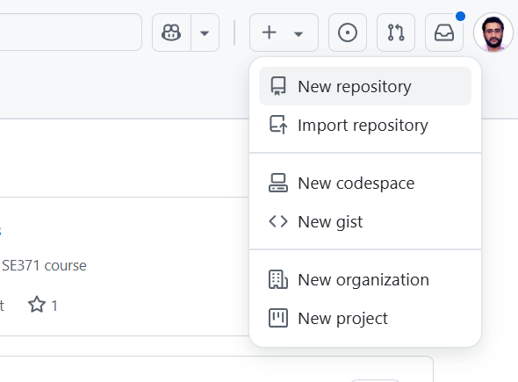

Then:

*Note: Add a README and a .gitignore to your repository.*

Part B: Clone the github repository locally (copy)

* Create a folder for your labs (for example on Desktop/labs_se411).
* Open a terminal on that folder.
* Clone your github repository into the labs_se411 folder:

git clone [your_github_repository_URI](https://github.com/skanderturki/se411_labs.git)

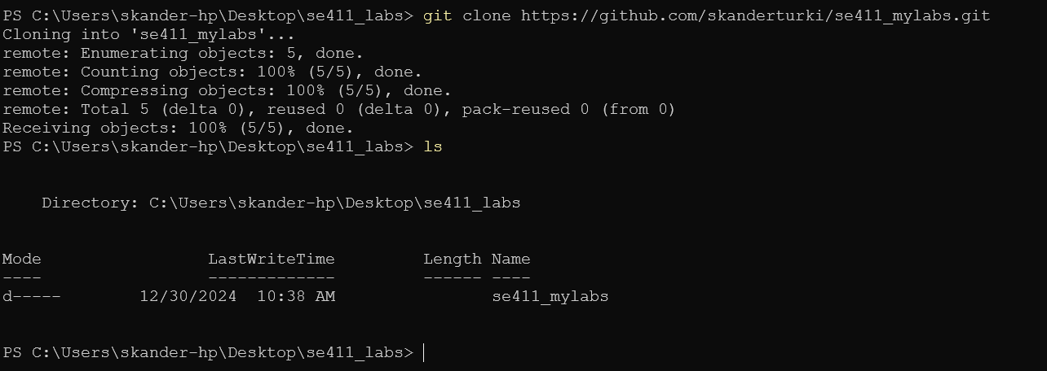

Part C: Working on our repository and sharing our code on github

* Open any text editor (VSCode is a perfect choice). You type “code .” to open VSCode on the current folder:



* Change the README.md on the root of your repository.

* Now, use a terminal (from inside VSCode or the same terminal that you have used before) and check the status of your local git repository.

You should see that you have modifications.

* We need to add these files to the staging area using *git add filename*

* Now, we can create our first commit to add the code to our local git repository using git commit -m “some message”:

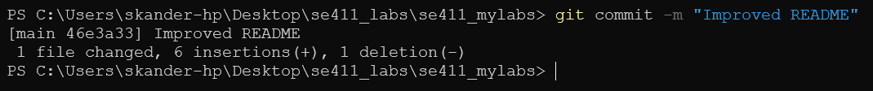

Part D: Working with the remote repository

* To get information about the repository that is configured to be the “remote” repository:

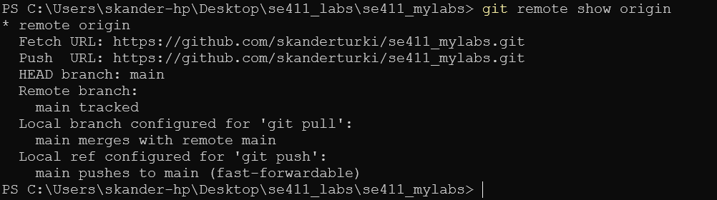

* The result shows that the reference “origin” points to the remote branch “main”
* Compare your local repository with “origin”:

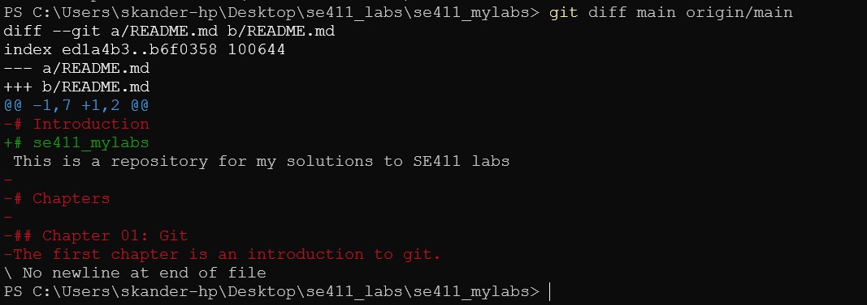

* Push your work to “origin”:

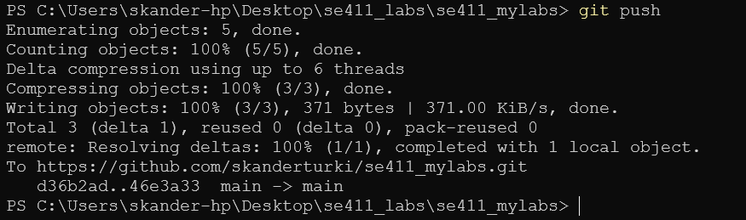

* Now refresh your github page, you should see the new README:
* 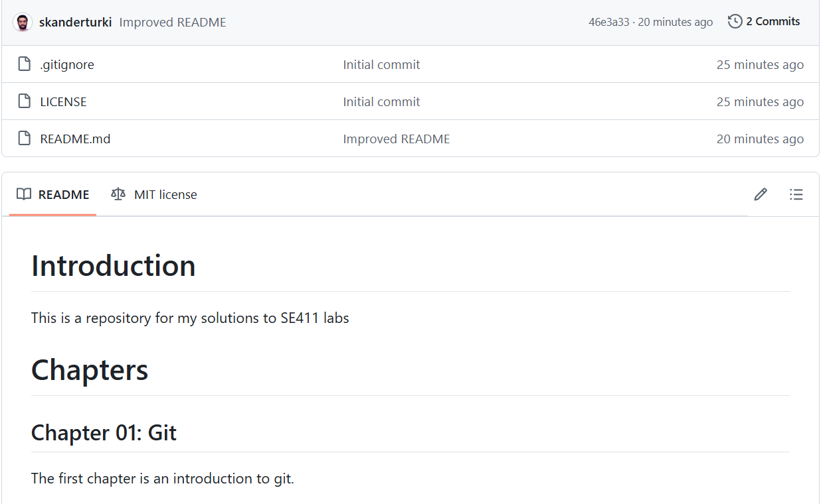

**END**